Brief Report

Distribution of Sex

Distribution of Class

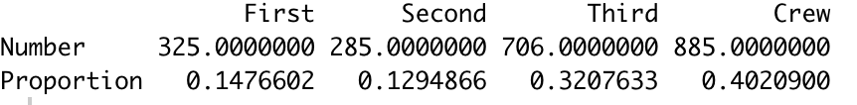

Distribution of Age

